Call Centre Application
You are required to develop a Call Centre menu system (similar to the bank system covered in class and the library system covered in practicals).  This will involve the development of three new classes:  - Call  - CallCentre  - CallCentreTester  You will use the EasyScanner for user input. | 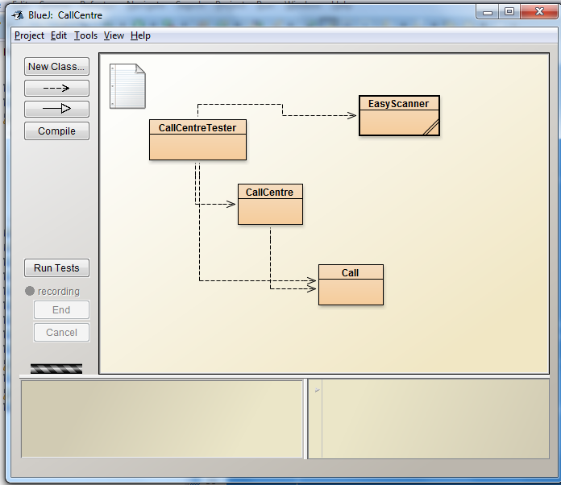

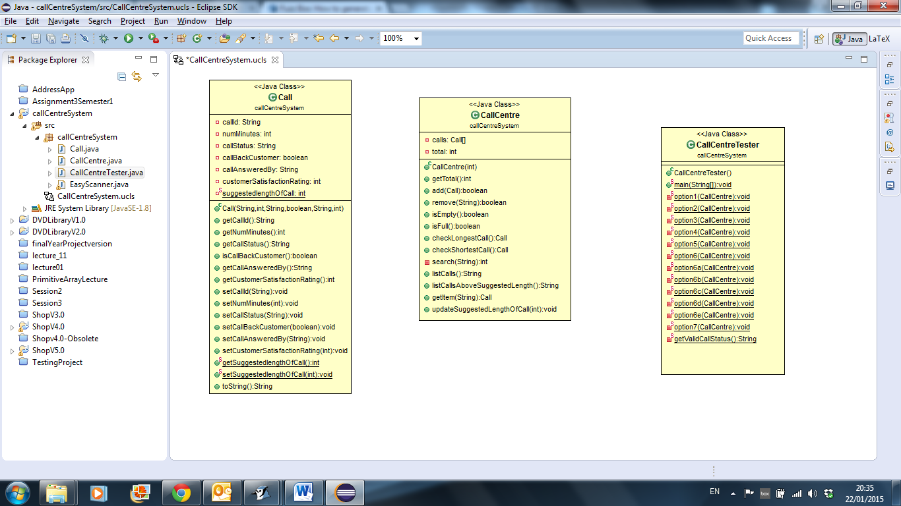 | The Call class.  This is a template / blueprint class for a Call. It stores data on the callId (String), numMinutes (int), callStatus (String), callBackCustomer (boolean), callAnsweredBy (String), customerSatisfactionRating (int). The constructor updates these instance variables with the information passed as a parameter.  It also stores a static variable, suggestedLengthOfCall (int).  You need an accessor and mutator method for each attribute (including the static variable).
The CallCentre class.

This class creates an array of calls and handles it. You will need to maintain a “total” field that will hold the number of calls stored in the system.

Typical methods would include (but not limited to):
  - the constructor will set the size of the array and set the number of calls to 0.
  - add a call to the system (to the array)
  - remove a call from the system
  - check if the system is empty
  - check if the system is full
  - return the total number of calls in the system
  - search the system for a call
  - show all of the calls stored in the system
  - a method to update the suggested length of a call for ALL calls (i.e. static).

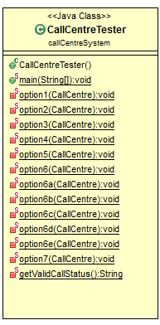 | The CallCentreTester class contains the main method. This class displays the menu repeatedly to the user. Note that there is a private method behind each option on the menu. | 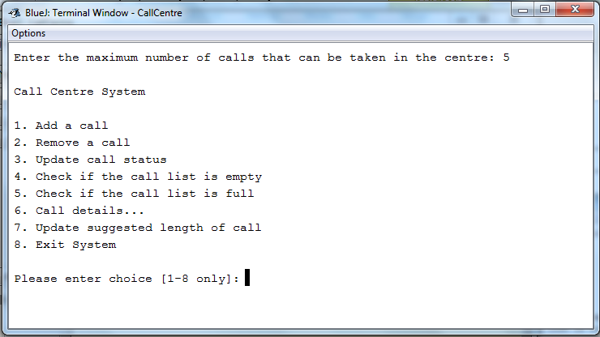
 | When the user selects option 6, a sub-menu is displayed to the user.  Please see the runtime version for the operation of these menus. | 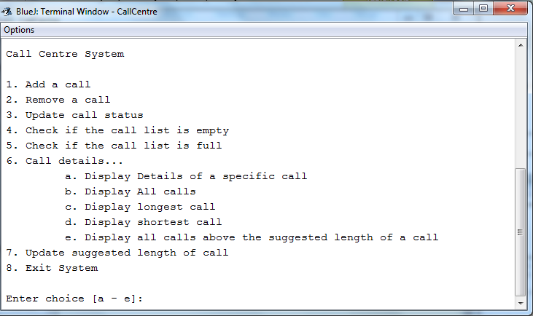

Important Points

- This project is worth 30% of your overall mark.
- This is an individual project. Absolutely NO team efforts allowed.
- Code MUST be commented.
- Your program MUST run as the sample program runs.
- Any sign of cheating/copying will result in a ZERO GRADE for all students regardless of who wrote the original code.
- By uploading your assignment, you are electronically signing the WIT anti-plagiarism declaration. Please see the WIT website for more details on this policy.
- You will be interviewed on your programs when they are submitted to determine authorship and understanding. These interviews will take place during your practical classes. Make a copy of your assignment for interview purposes and remove ALL comments prior to interview. You will only be interviewed on un-commented code.
- You must attend an interview on your code or it will result in a ZERO GRADE.
- You will receive a grade for your interview. This is a multiplier for your assignment grade.
- Late submissions will not be accepted.
- You must submit the fully commented project via moodle (zip and upload, folder called YourName).
- You must ensure you have uploaded the correct file as after the deadline no submission will be accepted.

